**Pivotal Cloud Foundry (PCF) :--**

**Spring Boot PCF deployment:--**

Pivotal Cloud Foundary is a Cloud Deployement Server provides service to Spring Boot and Microservices Applications mainly with all kinds of Environment setup like Databases, server, log tracers etc.

**#PCF Account Setup#**

**Step#1:-**  Goto <https://login.run.pivotal.io/login> And click on Create new account

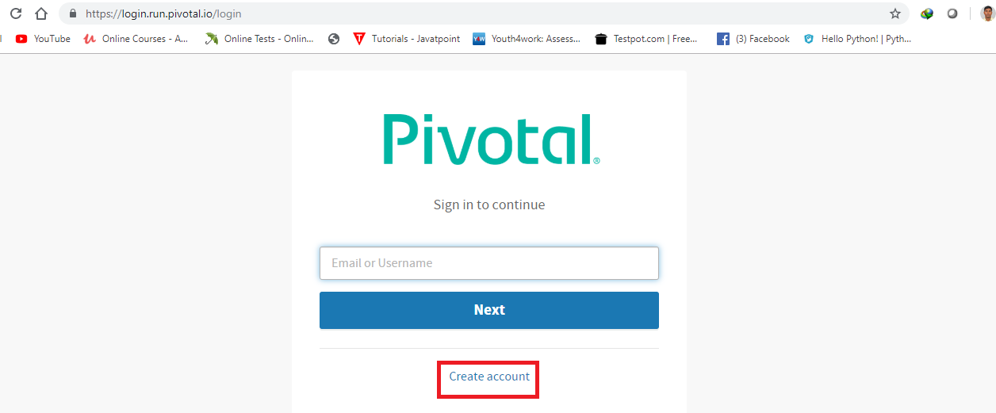

**Step#2:-** Enter details name, email, password and conform password Register

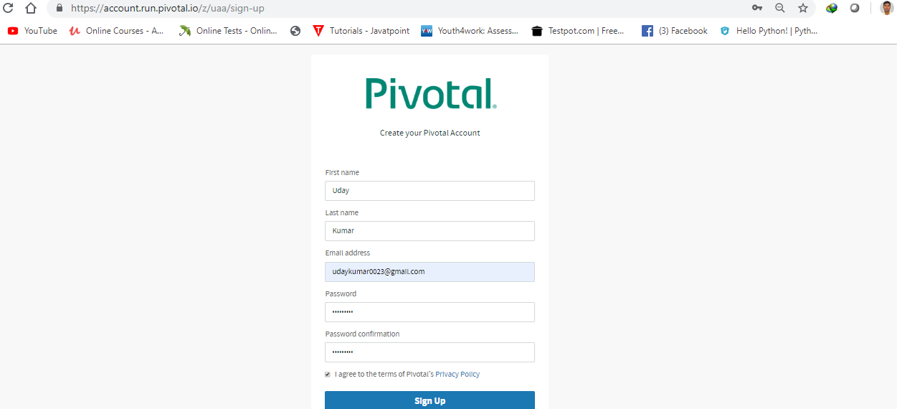

**Step#3:-** Goto Email Account and verify PCF link

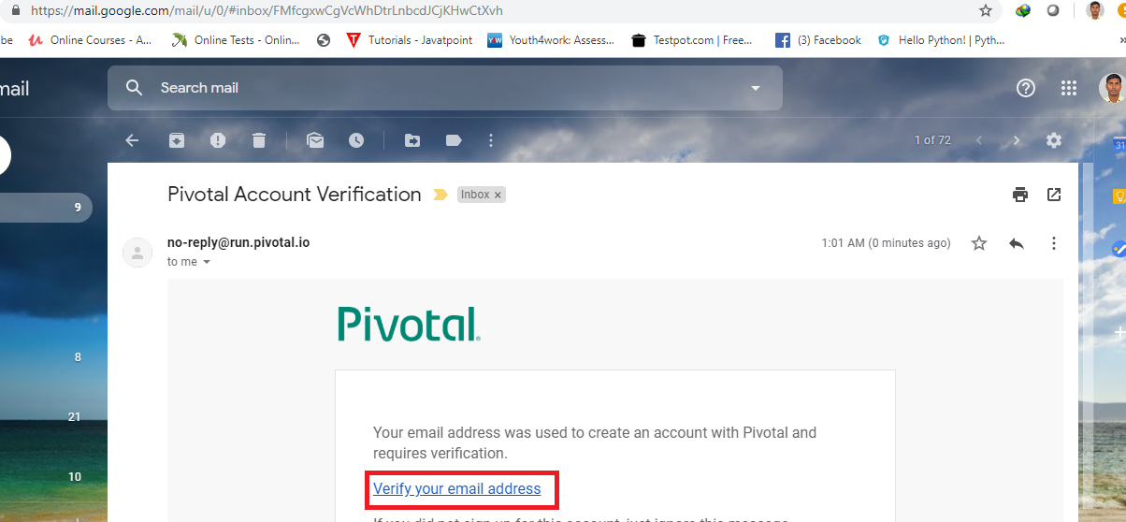

**Step#4:-** Login to PCF account (Above URL)

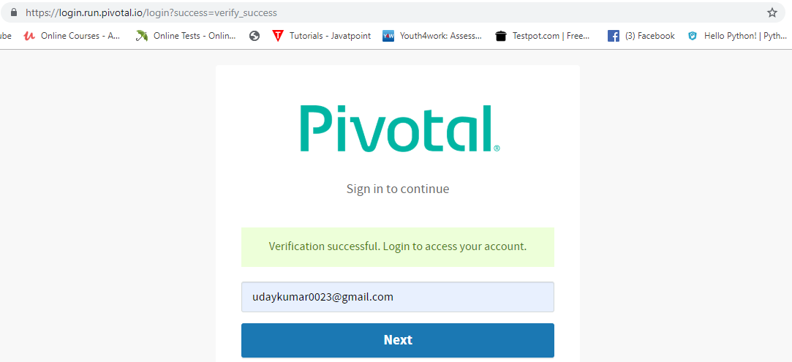

=>Click on pivotal web service

**Step#5:-** Provide initial details like

=>Company name

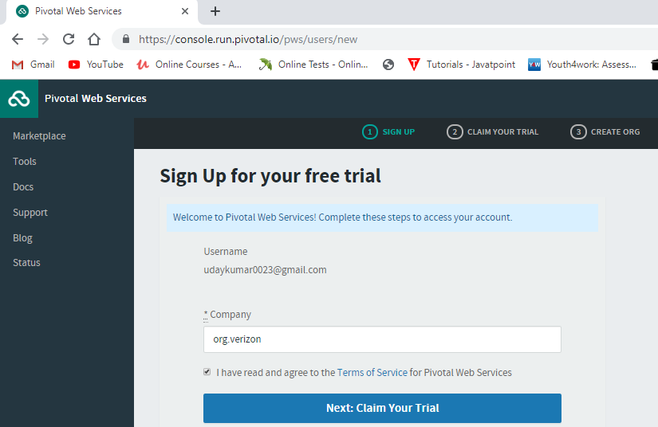

=>Mobile number and verify

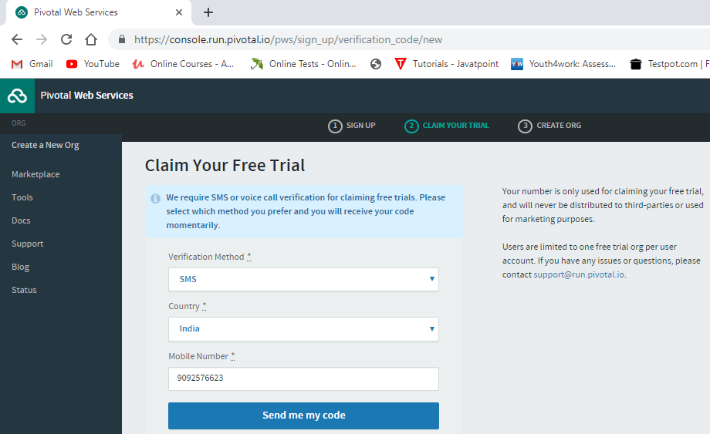

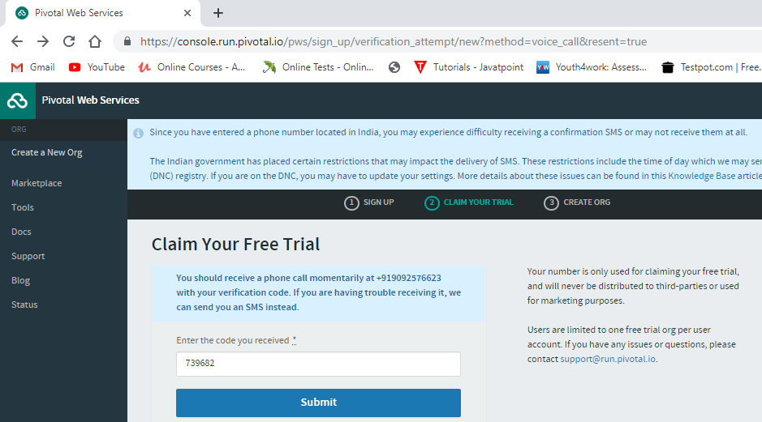

=>Organization (org) name > finish

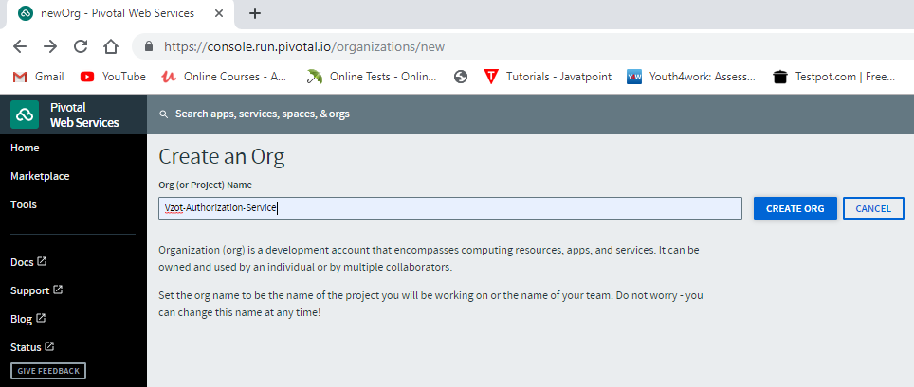

**Step#6:-** Download and setup PCF CLI

->Click on “Tools” option

->Choose OS and Bit and Download Software

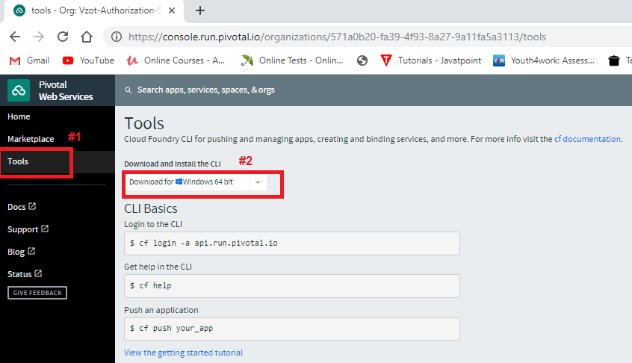

->Extract ZIP into Folder

->Click on “cf_installer.exe”.

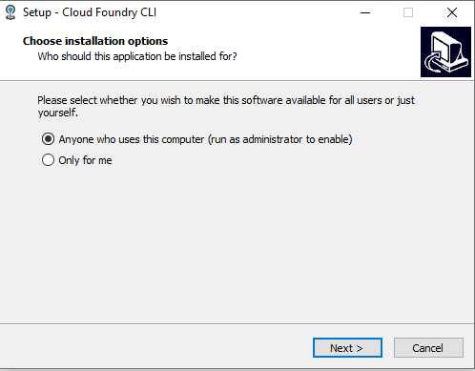

=>next

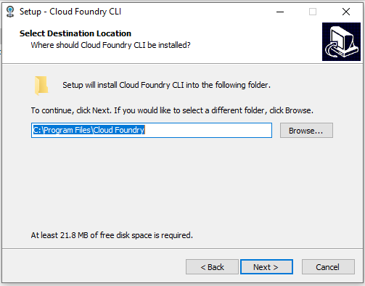

=>>next > next > Finish

Step#7 Login and Logout Commands

=>Goto cmd prompt

1>Login command is

cf login –a api.run.pivotal.io

Email >

Password >

2>Logout command is

cf logout

